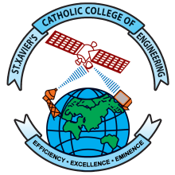
St. Xavier’s Catholic College of Engineering
An Autonomous Institution Affiliated to Anna University, Chennai
Accredited with Grade ‘A’ by NAAC
UG Programs CE, CSE, EEE, ECE, IT and ME Accredited by NBA
Recognized Under Section 2(f) and 12(B) of UGC Act 1956
Chunkankadai, Nagercoil – 629003
End-Semester Practical Examinations

Change of Internal Examiners

Sl. No. | Course Code | Course Title | Date(s) of Exam | Internal Examiner Appointed by CoE  (Name, Designation, Department) | Reason for the Change | New Internal Examiner Appointed by HoD  (Name, Designation, Department)
Enclose the permission letter submitted by the internal examiner with the recommendation of HoD and permission the Principal.

Signature of the HoD

