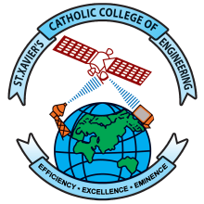
St. Xavier’s Catholic College of Engineering
An Autonomous Institution, Affiliated to Anna University, Chennai
Accredited with Grade ‘A’ by NAAC
UG Programs CE, CSE, EEE, ECE, IT and ME Accredited by NBA
Recognized Under Section 2(f) and 12(B) of UGC Act 1956
Chunkankadai, Nagercoil – 629003
End-Semester Practical Examinations

External Examiners Appointed by HoD

Sl. No. | Course Code | Course Title | Date(s) of Exam | External Examiner Appointed by CoE  (Name, Designation and Institution) | Reason for the Decline | External Examiner Appointed by HoD  (Name, Designation and Institution)

Signature of the HoD

