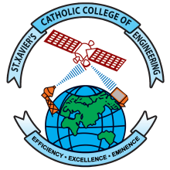 | St. Xavier’s Catholic College of Engineering  (Autonomous)  Chunkankadai, Nagercoil – 629003  End-Semester Practical Examination
Nov./Dec. ……… / April/May ……… Examinations
Question Set
Subject Code and Title:
Degree and Branch: Semester:
Department Conducting the Examination:
Date(s) and Time of the Examination: Regulations:

Scheme of Mark Allotment (No. of columns can be changed)
Scheme |  |  |  |  |  | Total
Marks |  |  |  |  |  | 100

Questions (No. of rows can be changed)
Qn. No. | Question

Signature of Internal Examiner |  | Signature of External Examiner
Name: |  | Name:
Designation: |  | Designation:
 |  | Institution:

