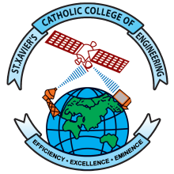 | St. Xavier’s Catholic College of Engineering  An Autonomous Institution Affiliated to Anna University Chennai  Chunkankadai, Nagercoil – 629003  End-Semester Practical Examination

Nov./Dec. YYYY / April/May YYYY Examinations
Department of …
Time Table
Subject Code and Title:
Degree and Branch:
Semester:
Venue:
Date | Time | Register Number | Total Students
DD-MM-YYYY | 9:15 a.m. to 12:15 p.m.
 | 1:00 p.m. to 4:00 p.m.
DD-MM-YYYY | 9:15 a.m. to 12:15 p.m.
 | 1:00 p.m. to 4:00 p.m.
Discrepancy, if any, can be brought to the knowledge of the HOD.

HOD Principal

